TREASURY REGISTER DOCUMENT 1 OF 4 REVISION B
Data model
Thirty-three tables across counterparty control, the deal lifecycle, the advisory layer and currency risk.
Revision A covered counterparty control and a minimal deal record. This revision covers all four subject areas of the process design, so the model is complete against the diagrams rather than against phase one of the build.
Design and build are separated deliberately. Section 4 marks every table with the phase that needs it, so a developer can build eighteen tables first and the model still holds when the rest arrive.
Companion documents: 2, application programming interface. 3, user interface. 4, architecture.

1. What changed from revision A
Change | Reason
Eighteen tables added | Confirmation and matching, amendments, accrual and journals, settlement, the advisory harness, currency exposure and hedging, and the bank statement line. Section 2 lists them by subject area.
policy_config becomes policy_version | It is now versioned with effective_from and superseded_at, and both deal and check_run record which version they were tested against. Limits were already versioned. The policy that produced them was not, which made a check reproducible only until somebody changed a threshold.
Accrual is stored, not computed on read | Correct for exposure, insufficient for accounting. The ledger needs what was recognised on each day, not a recomputation of what it should have been. Exposure still reads from the stored accrual rather than recomputing.
Confirmation is a first class table, not a column on the deal | The whole value of matching is that the two records arrive by different routes. Folding the confirmation into the deal leaves nothing to match against, and the control disappears.
Money gains a companion representation | Sterling amounts stay integer pence. Foreign currency amounts are integer minor units with an explicit currency column, because the euro obligations in the currency register are not pence and must never be added to anything that is.
counterparty exposure and currency exposure are permanently separated | Different tables, different names, different units, and a stated rule that no query joins them. Section 9.4 sets out why.

2. The model at a glance
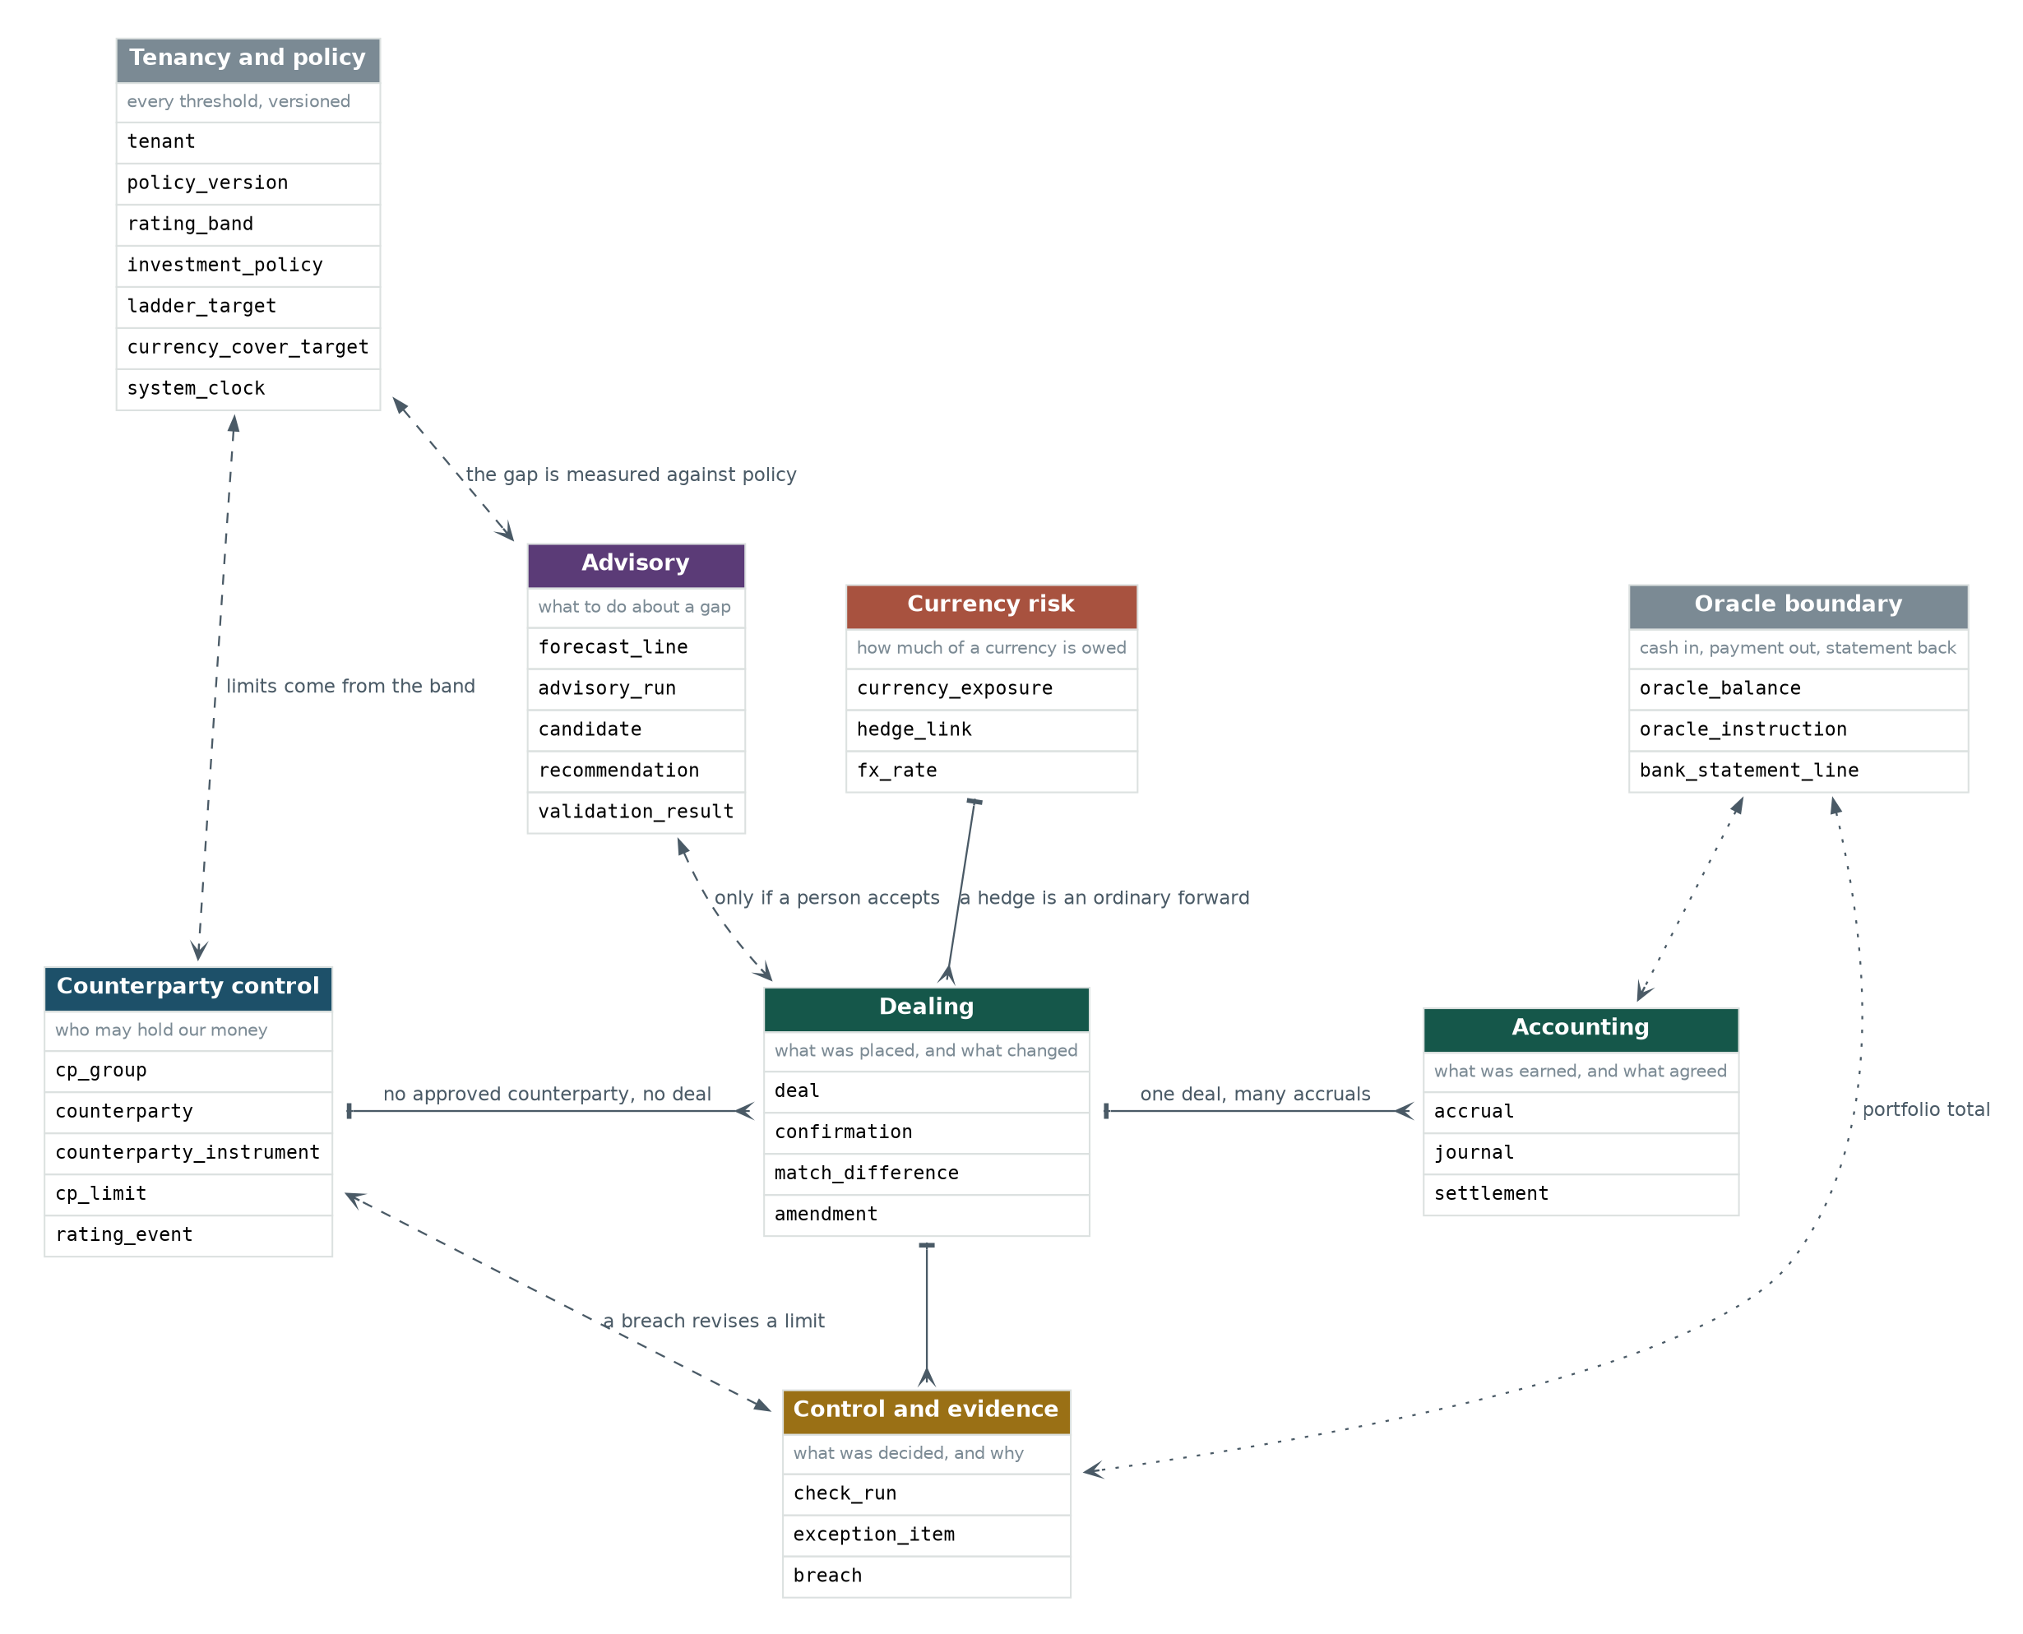
Figure 1. Thirty-three tables in eight subject areas, and how the areas depend on each other.
Four things this map is meant to settle. Counterparty control and dealing are not two systems, they share one database and meet at the limit a deal is tested against and the exposure it then creates. Accounting hangs off dealing rather than sitting beside it. The advisory layer reads policy and writes nothing to the book, so its only path into a deal runs through a person and then through the six checks. And currency risk touches dealing only because a hedge is an ordinary forward, which is why it needs no dealing tables of its own.

2.1 Tables by subject area and build phase
Subject area | Tables | Phase
Tenancy and policy | tenant, policy_version, rating_band, system_clock | 1
 | investment_policy, ladder_target, currency_cover_target | 2
Counterparty control | cp_group, counterparty, counterparty_instrument, cp_limit, rating_event | 1
Dealing | deal | 1
 | confirmation, match_difference, amendment | 3
Accounting and settlement | accrual, journal, settlement | 2 for accrual and journal, 3 for settlement
Control and evidence | check_run, exception_item, breach | 1
Advisory | forecast_line, advisory_run, candidate, recommendation, validation_result | 2
Currency risk | currency_exposure, hedge_link, fx_rate | 3
Oracle boundary | oracle_balance, oracle_instruction | 1
 | bank_statement_line | 3
Eighteen tables in phase one, twenty-six by the end of phase two, thirty-three by the end of phase three. The phase one set is unchanged from revision A apart from the policy versioning, so nothing already designed has to be rebuilt.

3. Conventions

3.1 Representation
Concern | Representation | Reason
Sterling money | Integer pence. Suffix _pence. | Never floating point. A rounding drift on a limit check is the one defect a treasury audience will not forgive.
Foreign currency money | Integer minor units. Suffix _minor, with a currency column alongside it, always. | A euro obligation is not pence. Giving it a different suffix makes an accidental addition to a pence column visible in the code rather than only in the result.
Rates and percentages | Integer basis points. Suffix _bp. | 4.20 per cent is 420. A 30 per cent cap is 3000.
Exchange rates | Integer scaled by one hundred million. Suffix _e8. | Basis points are too coarse for a rate. Eight decimal places is the market convention and stays exact in integers.
Business dates | ISO 8601 text, YYYY-MM-DD. Suffix _date. | SQLite has no date type. ISO text sorts and compares correctly as text.
Event timestamps | ISO 8601 text. Suffix _at. | Date resolution in this build. Section 13 covers the change under PostgreSQL.
Identifiers | Text, prefixed, random suffix. | Readable on screen and in a log. Stable across a database move. No sequence to reset when reseeded.
Booleans | Integer 0 or 1, with a check constraint. | SQLite has no boolean type.
Structured payloads | JSON in a text column. Only results_json, alternatives_json and payload. | All three are evidence, written once and read whole, never queried by content.

3.2 Rules that hold across every table
Rule | Detail
Nothing is deleted | Superseding a limit, resolving an exception, responding to a breach, reversing an accrual and unlinking a hedge are all writes. There is no delete path and no soft delete flag.
Every operational table carries tenant_id | One seeded value in this build, never queried differently.
A null has exactly one meaning per column | Stated in the column table. Where a null is significant, for example superseded_at meaning current, it is called out.
Nothing computed is stored, with one deliberate exception | Exposure, headroom, coverage and the portfolio total are all derived. Accrual is stored, because the accounting record of what was recognised on a day is a fact rather than a calculation. Section 9 sets out both.
A correction is an entry, not an edit | An amended deal produces reversing accruals and reversing journals. The original rows stay, marked with what reversed them.

4. Entity relationship diagrams
Three detailed views, one per new subject area. Counterparty control is unchanged from revision A apart from the policy versioning and appears in section 5.

4.1 Dealing, accounting and settlement
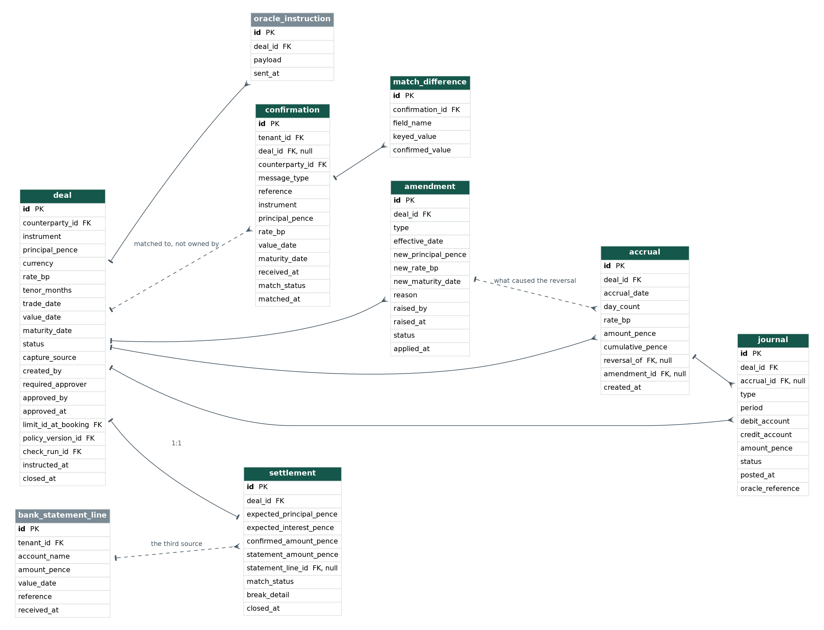
Figure 2. Model 2 of the process design, in full.
The deal is the spine. A confirmation arrives independently and is matched to it rather than owned by it, which is the only reason matching is a control. An amendment causes reversing accruals, and those reversals carry the amendment that caused them. Settlement is where three sources have to agree, and two of three agreeing is not enough.

4.2 The advisory layer
Read the direction of the arrows. Policy and forecast flow in. Candidates and a recommendation flow out. The only edge into the deal table is dashed and labelled, because nothing is recorded because a model suggested it.
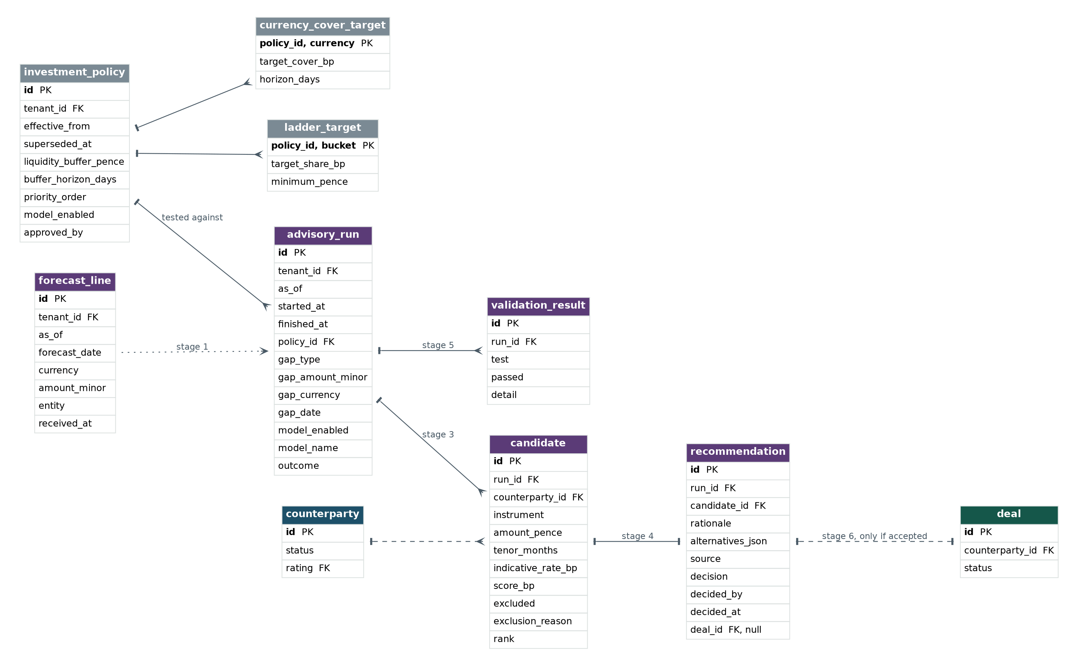
Figure 3. Model 3 of the process design. One nightly run, and the evidence it leaves.

4.3 Currency risk
Three tables. An obligation, the forwards linked to it, and the rates used to value them. The forward itself is an ordinary row in the deal table, which is why there is no separate hedge table.
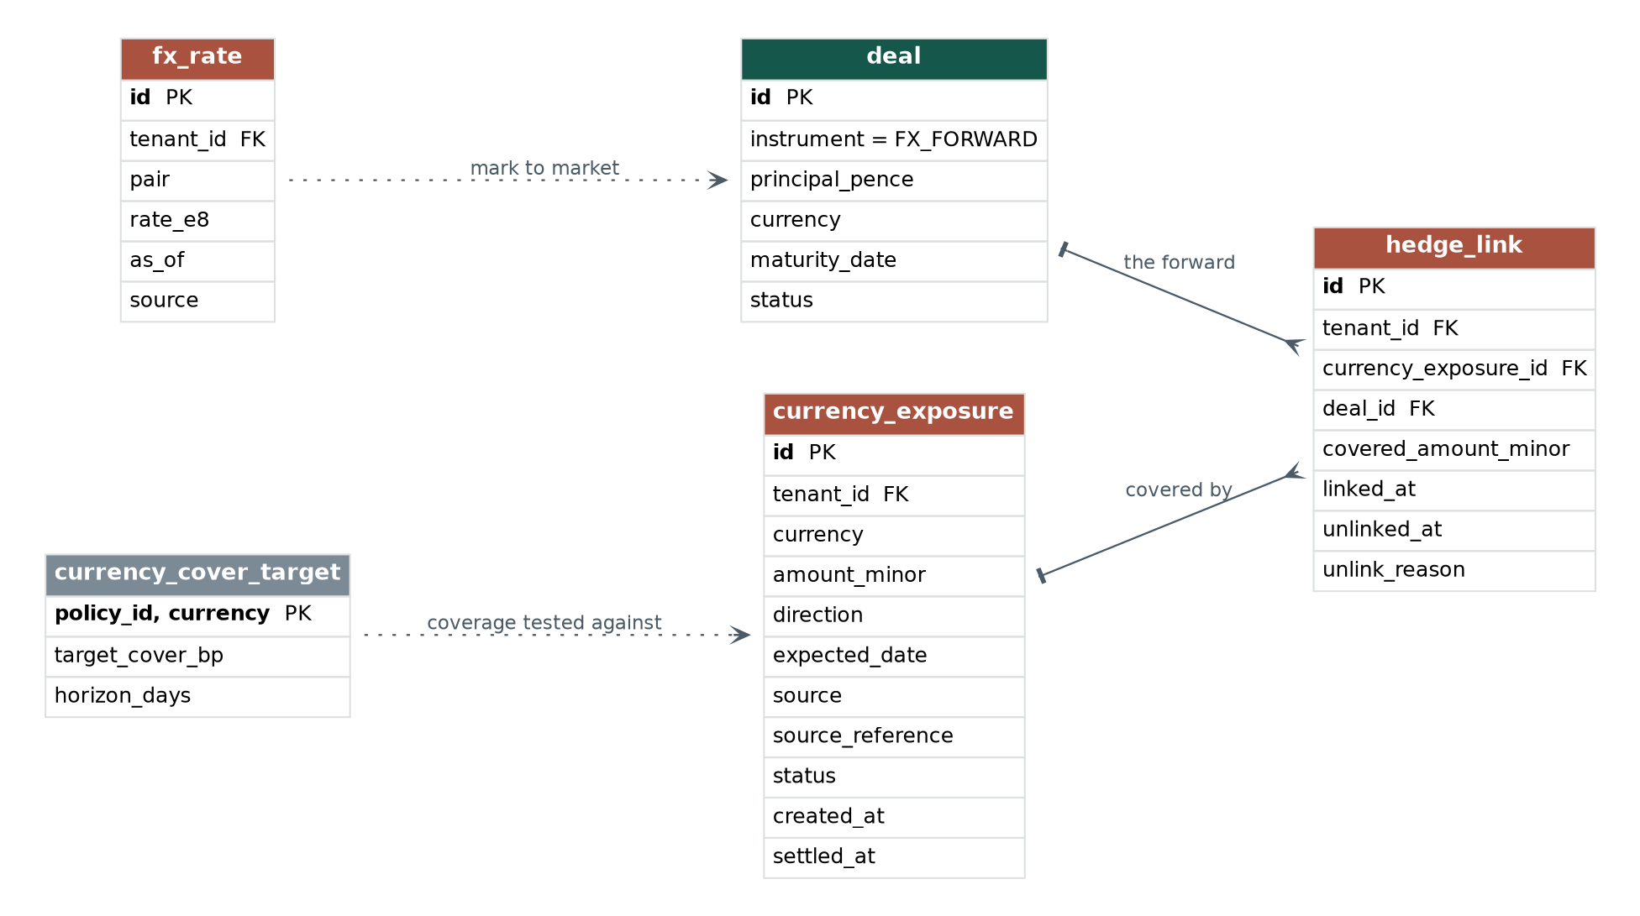
Figure 4. Model 4 of the process design. Only the exposure side is new.

5. Entity catalogue, counterparty control
Unchanged from revision A except for policy_version. Reproduced here so the document stands alone.
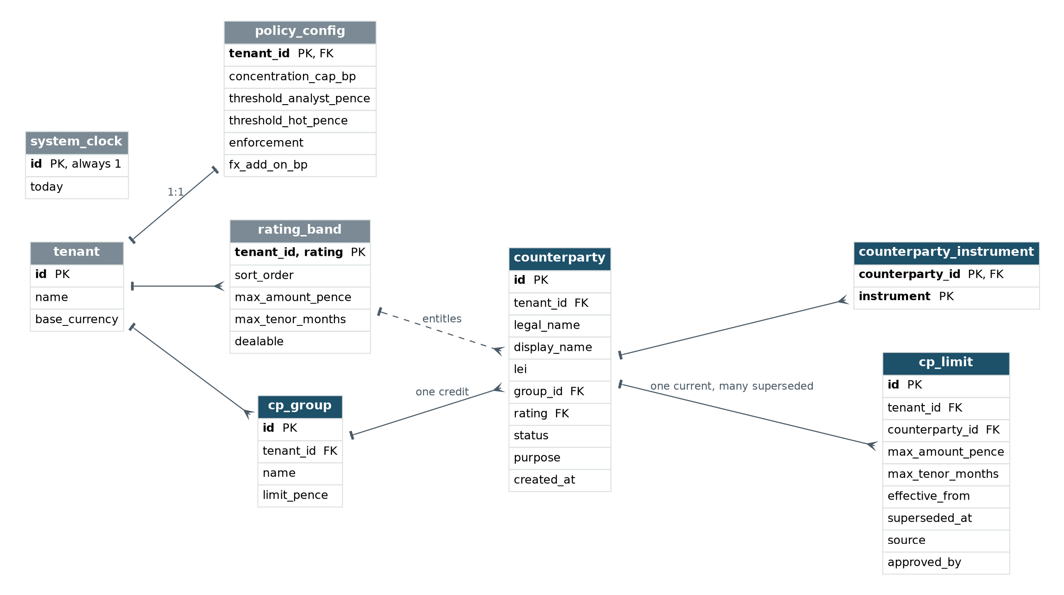
Figure 5. Tenancy, policy and the counterparty tables.

policy_version
The treasury policy in force. Versioned, so a check made last quarter can be reproduced against the rules that applied then.
Column | Type | Null | Description
id | text | no | Primary key. Referenced by deal and check_run.
tenant_id | text | no
effective_from | text | no | The date this version came into force.
superseded_at | text | yes | Null means current. A partial unique index enforces one current version per tenant.
concentration_cap_bp | integer | no | Maximum share of the portfolio one credit group may hold.
threshold_analyst_pence | integer | no | At or below this, an analyst may sign.
threshold_hot_pence | integer | no | At or below this, the Head of Treasury signs. Above it, the CFO.
enforcement | text | no | HARD_BLOCK or WARN_WITH_OVERRIDE.
fx_add_on_bp | integer | no | The add on applied to a forward's notional when measuring counterparty exposure.
approved_by | text | no | Who signed this version of the policy.
This is the change that closes the reproducibility gap in revision A. A check run now records both the limit version and the policy version, so every input to a historic decision is recoverable rather than only the ones that happened not to change.
The remaining counterparty control tables are unchanged: tenant, rating_band, system_clock, cp_group, counterparty, counterparty_instrument, cp_limit, rating_event, check_run, exception_item and breach. Their columns are as set out in revision A, with two additions: deal gains policy_version_id and capture_source, and check_run gains policy_version_id.

6. Entity catalogue, dealing

deal
What was placed, with whom, on what terms, and under which limit and policy version. Two columns are new in this revision.
Column | Type | Null | Description
id | text | no | Primary key.
tenant_id, counterparty_id | text | no | Foreign keys.
instrument | text | no | DEPOSIT, FX_FORWARD, MMF or GILT.
principal_pence | integer | no | Face amount. Never the exposure figure.
currency | text | no | The currency of the principal. Sterling for a deposit. For a forward, the currency bought.
rate_bp | integer | no | The contracted rate, or the forward rate.
tenor_months | integer | no | Stored rather than derived, because the tenor check reads it directly.
trade_date, value_date, maturity_date | text | no, no, yes | Maturity is null for open ended holdings.
status | text | no | PROPOSED, BLOCKED, ACTIVE, MATURED, CLOSED or CANCELLED. MATURED is new, and separates a position that is due from one that has been reconciled and closed.
capture_source | text | no | NEW. KEYED or FROM_CONFIRMATION. Auto creating from the confirmation removes the keying error rather than catching it later, and which route was used is worth keeping.
created_by, required_approver, approved_by, approved_at | text | no, yes, yes, yes
limit_id_at_booking | text | yes | Which limit version the deal passed against.
policy_version_id | text | yes | NEW. Which policy version the checks read.
check_run_id | text | yes | The evidence of the gate decision.
instructed_at, closed_at | text | yes | closed_at is new, set by settlement.

confirmation
The counterparty's own record of what was agreed, arriving by a different route from the deal. Without it you only have your own word for what was traded.
Column | Type | Null | Description
id | text | no | Primary key.
tenant_id | text | no
deal_id | text | yes | Null until matched. A confirmation can arrive before the deal is keyed, or for a deal that was never keyed at all, and both cases are the point.
counterparty_id | text | yes | Resolved from the message. Null when it cannot be.
message_type | text | no | MT300, MT320, MT535, MT536, BROKER_NOTE or DOCUMENT.
reference | text | no | The bank's own reference.
instrument | text | no | As stated by the counterparty.
principal_pence, rate_bp, value_date, maturity_date | mixed | no | The confirmed terms, held separately from the keyed terms so the two can be compared rather than merged.
received_at | text | no | When it arrived.
match_status | text | no | UNMATCHED, MATCHED, MISMATCHED or DISPUTED.
matched_at | text | yes
raw_payload | text | yes | The original message, kept whole. Never parsed twice.

match_difference
What disagreed, field by field. One row per field, so the interface can say the rate was keyed at 4.30 and confirmed at 4.28 rather than reporting a mismatch.
Column | Type | Null | Description
id | text | no | Primary key.
confirmation_id | text | no | Foreign key.
field_name | text | no | principal_pence, rate_bp, value_date, maturity_date or instrument.
keyed_value | text | no | As text, because the fields have different types and this table exists to be displayed rather than computed on.
confirmed_value | text | no

amendment
A break, roll, partial drawdown or correction. The second and last time a person touches a deal.
Column | Type | Null | Description
id | text | no | Primary key.
deal_id | text | no | Foreign key.
type | text | no | BREAK, ROLL, PARTIAL_DRAWDOWN or CORRECTION.
effective_date | text | no | The date from which the new terms apply. Everything recognised after this date has to be recalculated.
new_principal_pence, new_rate_bp, new_maturity_date | mixed | yes | Only the terms that changed. A null means unchanged.
reason | text | no | Why. Required, because an amendment that reverses posted journals needs an explanation.
raised_by, raised_at | text | no
status | text | no | RAISED, APPLIED or REJECTED.
applied_at | text | yes | When the recalculation and the reversals completed.
Recalculating is the easy half. Knowing what was already recognised is the hard half, and that is only possible because accrual is stored per day rather than computed on read.

7. Entity catalogue, accounting and settlement

accrual
What was recognised, per deal, per day. Stored rather than recomputed.
Column | Type | Null | Description
id | text | no | Primary key.
tenant_id, deal_id | text | no | Foreign keys.
accrual_date | text | no | The day this amount was earned. One row per deal per day.
day_count | integer | no | Usually one. More after a gap, and the column makes the gap visible.
rate_bp | integer | no | The rate used on that day. An amendment changes it from the effective date onward, and the old rows keep the old rate.
amount_pence | integer | no | Signed. Negative on a reversal.
cumulative_pence | integer | no | Running total to this date. Denormalised on purpose, because the alternative is a window function on every read of the blotter.
reversal_of | text | yes | The accrual row this one reverses. Null on an original.
amendment_id | text | yes | What caused the reversal.
created_at | text | no

journal
What the accounting entry should be. The platform works it out. Oracle posts and keeps it.
Column | Type | Null | Description
id | text | no | Primary key.
tenant_id, deal_id | text | no | Foreign keys.
accrual_id | text | yes | Null for a settlement or revaluation entry.
type | text | no | ACCRUAL, SETTLEMENT, REVALUATION or REVERSAL.
period | text | no | The accounting period, as YYYY-MM. Whether a closed period can be reopened is an accounting policy decision rather than a technical one, and this column is where it bites.
debit_account, credit_account | text | no | From the mapping. Deposit interest, an FX gain and a gilt coupon go to different accounts, and Oracle cannot hold that mapping because the deal does not exist there.
amount_pence | integer | no | Signed.
status | text | no | BUILT, POSTED or FAILED.
posted_at | text | yes
oracle_reference | text | yes | What Fusion returned. The only evidence that the entry landed.

settlement
Maturity and close. Where three sources have to agree.
Column | Type | Null | Description
id | text | no | Primary key.
tenant_id, deal_id | text | no | One settlement per deal.
expected_principal_pence, expected_interest_pence | integer | no | What the deal record says should arrive.
confirmed_amount_pence | integer | yes | What the counterparty's confirmation says.
statement_amount_pence | integer | yes | What the bank statement shows.
statement_line_id | text | yes | The statement line it matched to.
match_status | text | no | PENDING, AGREED or BREAK.
break_detail | text | yes | Which two of the three agree, and by how much the third differs. Two of three agreeing is not enough: if the record and the confirmation agree but the statement differs, the money did not arrive as promised.
closed_at | text | yes | When the deal was closed and the headroom released.

bank_statement_line
The third source. Supplied by Oracle, prior day rather than intraday.
Column | Type | Null | Description
id | text | no | Primary key.
tenant_id | text | no
account_name | text | no
amount_pence | integer | no | Signed. Negative on a payment out.
value_date | text | no
reference | text | yes | What the bank quoted. Usually, but not always, the deal reference.
received_at | text | no

8. Entity catalogue, the advisory layer
Eight tables. Three hold the policy the gap is measured against, one holds the forecast, and four hold what a run produced. Nothing here writes to a deal.

investment_policy
The buffer, the ladder and the cover targets. Versioned, like the treasury policy.
Column | Type | Null | Description
id | text | no | Primary key.
tenant_id | text | no
effective_from, superseded_at | text | no, yes | Null superseded_at means current. One current version per tenant.
liquidity_buffer_pence | integer | no | Cash that must remain available.
buffer_horizon_days | integer | no | Over what period the buffer must hold.
priority_order | text | no | The order of security, liquidity and yield. This is what the ranking stage is told to optimise for, and it is data rather than a prompt.
model_enabled | integer | no | 0 or 1. Switching it off drops ranking to a weighted score. The recommendation survives, only the explanation is lost.
approved_by | text | no
The process design flags that this policy may not exist at the customer yet. If so, the absence is a blocker for the advisory layer and an opportunity to shape the policy, and the table is where that conversation lands.

ladder_target
What share of the portfolio should mature in each bucket.
Column | Type | Null | Description
policy_id | text | no | Primary key, part one.
bucket | text | no | Primary key, part two. 0_3M, 3_6M, 6_12M or OVER_12M.
target_share_bp | integer | no | The target share of the portfolio for this bucket.
minimum_pence | integer | no | An absolute floor, for when the portfolio is small enough that a share is meaningless.

currency_cover_target
How much of a currency obligation must be hedged, and how far out.
Column | Type | Null | Description
policy_id | text | no | Primary key, part one.
currency | text | no | Primary key, part two.
target_cover_bp | integer | no | Required coverage. 8000 is 80 per cent.
horizon_days | integer | no | How far ahead the target applies.

forecast_line
The forecast from Oracle EPM. Interface I-9. Without it the advisory layer has nothing to test.
Column | Type | Null | Description
id | text | no | Primary key.
tenant_id | text | no
as_of | text | no | The date the forecast was produced. A forecast is a statement made on a day and it is not corrected in place.
forecast_date | text | no | The day the money is expected to move.
currency | text | no
amount_minor | integer | no | Signed. Positive on an inflow. Minor units of the stated currency.
entity | text | yes | Which part of the organisation.
received_at | text | no

advisory_run
One nightly run. Written whether or not a model was called, and whether or not a gap was found.
Column | Type | Null | Description
id | text | no | Primary key.
tenant_id | text | no
as_of | text | no | The clock date the run read.
started_at, finished_at | text | no, yes
policy_id | text | no | Which investment policy version the gap was measured against.
gap_type | text | no | CASH_SURPLUS, CASH_SHORTFALL, LADDER_GAP, CURRENCY_UNCOVERED or NONE. With NONE the model is never called.
gap_amount_minor, gap_currency, gap_date | mixed | yes | The gap. Null when the type is NONE.
model_enabled | integer | no | As it stood at the time of the run, not as it stands now.
model_name | text | yes | Which model was called. Null when it was not.
outcome | text | no | NO_GAP, MODEL_ACCEPTED, MODEL_REJECTED_FALLBACK or RULE_ONLY.

candidate
The options the rules produced, priced. Excluded options are kept, because why was X not picked is the question that gets asked.
Column | Type | Null | Description
id | text | no | Primary key.
run_id | text | no | Foreign key.
counterparty_id | text | no | Foreign key.
instrument | text | no
amount_pence | integer | no
tenor_months | integer | no
indicative_rate_bp | integer | no | Computed at this stage. The model never generates a rate, and this column is where every figure in the recommendation comes from.
score_bp | integer | no | The deterministic score, computed whether or not the model runs, so the fallback is always available.
excluded | integer | no | 0 or 1. Excluded candidates never reach the model.
exclusion_reason | text | yes | Why. For example, three months is its ceiling at BBB+ and the gap runs longer.
rank | integer | yes | Where the model or the score placed it.

recommendation
What was proposed and what a person did about it.
Column | Type | Null | Description
id | text | no | Primary key.
run_id | text | no | Foreign key.
candidate_id | text | no | The chosen candidate. A foreign key, which is what makes an invented counterparty structurally impossible.
rationale | text | yes | The model's prose. Null when the fallback produced the pick.
alternatives_json | text | no | The candidates not picked, with their reasons, kept as shown.
source | text | no | MODEL or RULE_FALLBACK. Shown to the user, not hidden.
decision | text | yes | ACCEPTED, EDITED, REJECTED or EXPIRED. Null while outstanding.
decided_by, decided_at | text | yes
deal_id | text | yes | Set only if it became a deal, and only after that deal passed the six checks.
The disagreement log is the most valuable data this produces. Every rejection with its reason is a record of where the ranking disagreed with a treasurer, and that is worth more than the ranking itself.

validation_result
Three tests, all of which must pass. One row each, so a failure names itself.
Column | Type | Null | Description
id | text | no | Primary key.
run_id | text | no | Foreign key.
test | text | no | ID_IS_REAL, CHECKS_RERUN_CLEAN or FIGURES_AGREE.
passed | integer | no | 0 or 1.
detail | text | yes | What failed, where it failed.

9. Entity catalogue, currency risk

currency_exposure
A future obligation in another currency. It exists before any hedge and often outlives several of them.
Column | Type | Null | Description
id | text | no | Primary key.
tenant_id | text | no
currency | text | no | Always present. There is no default currency on this table.
amount_minor | integer | no | Minor units of that currency. Not pence, and the suffix says so.
direction | text | no | PAYABLE or RECEIVABLE. Inflows offset outflows, and hedging the gross is buying cover you do not need.
expected_date | text | no | When the money is expected to move.
source | text | no | CONTRACT, PURCHASE_ORDER, INVOICE or FORECAST.
source_reference | text | yes | The purchase order or contract number.
status | text | no | IDENTIFIED, PARTIALLY_COVERED, COVERED or SETTLED.
created_at, settled_at | text | no, yes

hedge_link
What covers what. The step that makes it hedging rather than owning forwards.
Column | Type | Null | Description
id | text | no | Primary key.
tenant_id | text | no
currency_exposure_id | text | no | Foreign key.
deal_id | text | no | Foreign key to the FX forward. An ordinary deal row.
covered_amount_minor | integer | no | One forward can cover several exposures and one exposure can take several forwards, so the amount lives on the link rather than on either end.
linked_at | text | no
unlinked_at | text | yes | Null while the link holds.
unlink_reason | text | yes | ROLLED, CLOSED_EARLY, EXPOSURE_CANCELLED or REALLOCATED.

fx_rate
Rates used to value a forward and to convert an obligation.
Column | Type | Null | Description
id | text | no | Primary key.
tenant_id | text | no
pair | text | no | For example GBPEUR. Always in one direction, so nothing has to guess which way to divide.
rate_e8 | integer | no | The rate scaled by one hundred million.
as_of | text | no | One rate per pair per date.
source | text | no | Where it came from. Stubbed in this build.

9.4 Two different things are called exposure
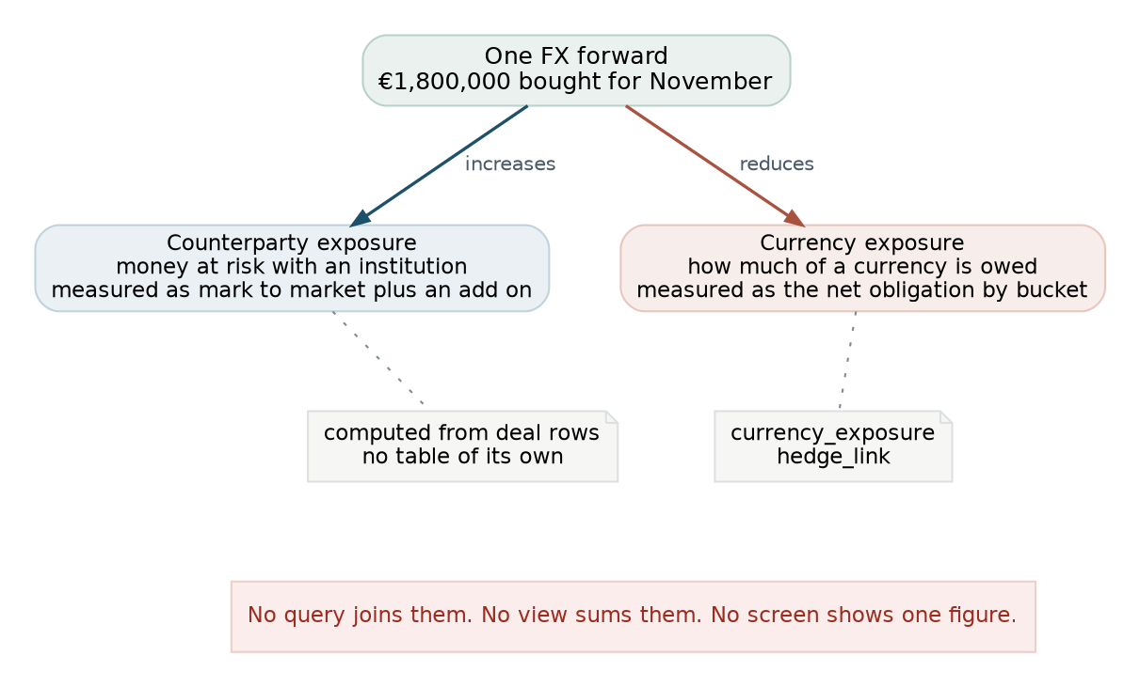
Figure 6. Same word, opposite direction, separate tables.
This is the single most likely modelling mistake in the whole system, and the defence is structural rather than documentary.
Rule | Enforcement
They never share a table | Counterparty exposure has no table. It is computed from deal rows. Currency exposure has its own.
They never share a unit | Counterparty exposure is pence. Currency exposure is minor units with an explicit currency.
They never share a name | No column, view or function is called exposure without a qualifier.
No query joins them | There is no key that would let one. currency_exposure has no counterparty_id, because an obligation to a supplier is not an obligation to a bank.
No screen shows one figure | The interface puts them on separate tabs that cannot be open at once, which document 3 covers.

10. Derived data
Four figures are computed on every read. One is stored, and the exception is deliberate.
Figure | Definition | Stored
Entity exposure | Sum of the measure over active deals for one counterparty. | No
Group exposure | Same, joined to counterparty on group_id. | No
Portfolio total | Same over all active deals, plus the Oracle balance as of the clock date. | No
Currency coverage | Net obligation by currency and time bucket, less the sum of covered_amount_minor on live hedge links, against the policy target. | No
Accrual | Interest earned per deal per day. | Yes
Accrual is the exception because it is not the same kind of thing. Exposure answers what is true now, and recomputing it is the only way to be sure it agrees with the deals behind it. An accrual answers what was recognised on the third of October, which is a historic fact that a later recomputation would quietly rewrite. Once a journal has been posted against it, changing it is a reversal rather than a recalculation.
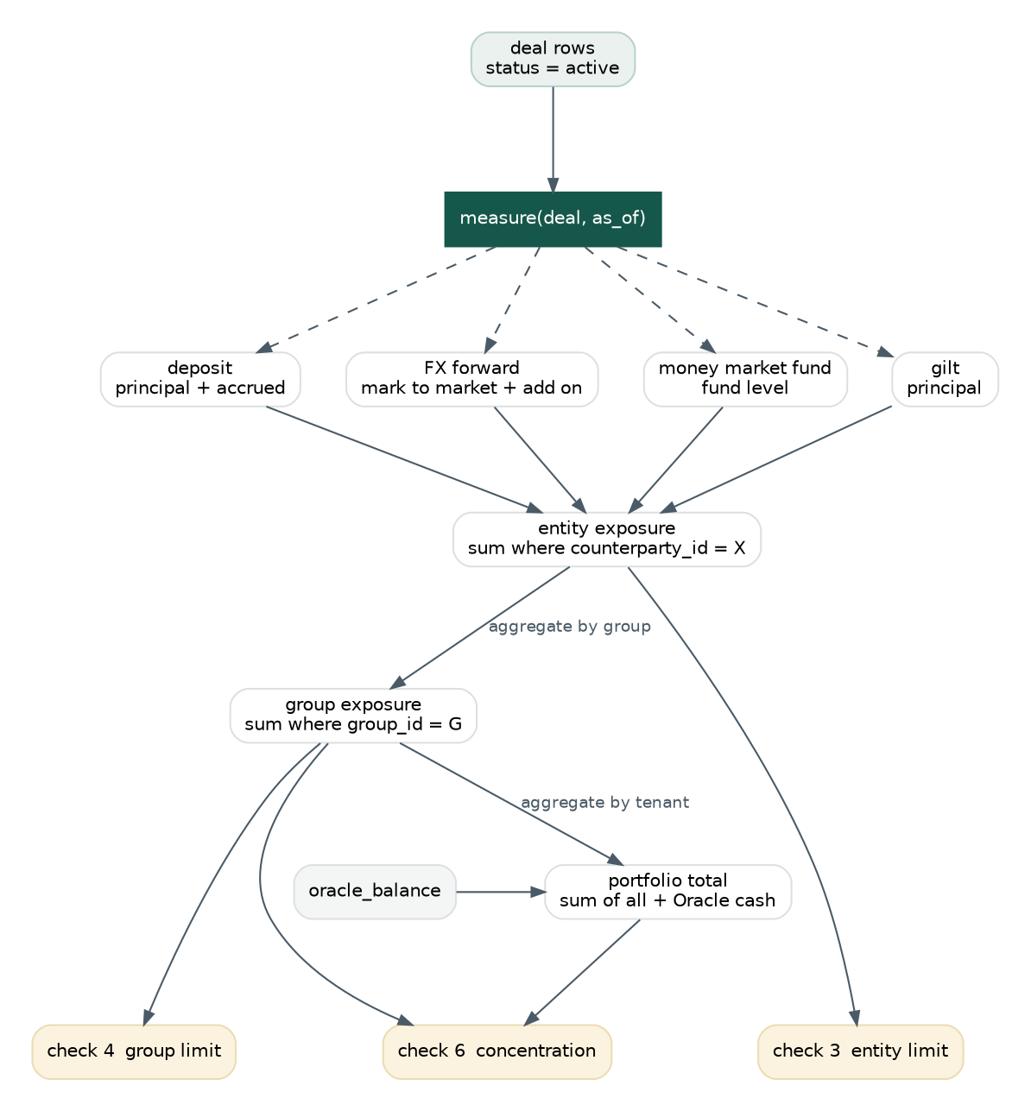
Figure 7. How counterparty exposure is derived, and which checks read which aggregation.

11. Lifecycles
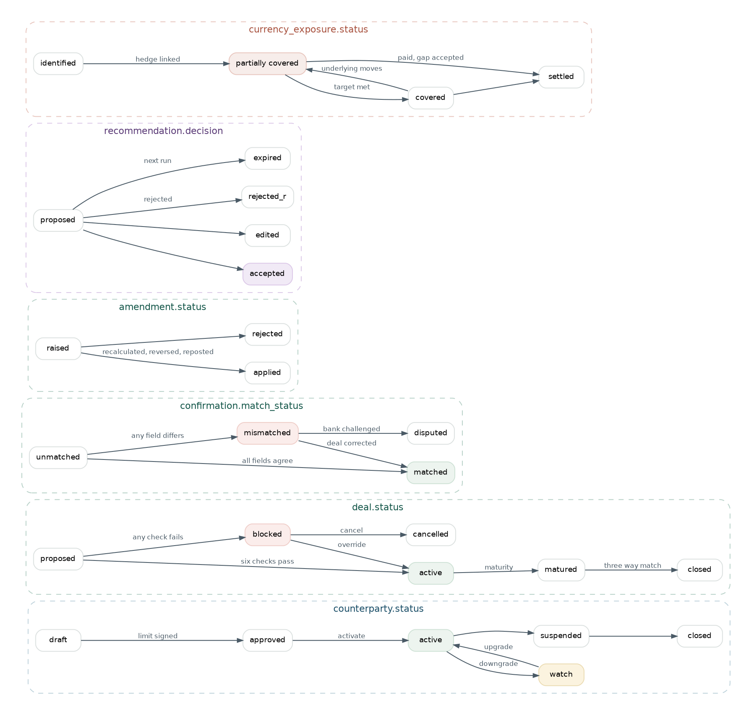
Figure 8. Permitted transitions across all four subject areas. Anything not drawn is not allowed.
Transition | Why it matters
counterparty approved to active | The boundary between the slow onboarding loop and the fast per deal loop. The only thing that puts a name in front of a dealer.
deal blocked to active | The override. The only transition that requires a recorded reason.
deal active to matured to closed | Matured means due. Closed means three sources agreed. Until closed, the counterparty's headroom is still consumed.
confirmation mismatched to matched | Reached by correcting the deal, which reruns the six checks, because a corrected rate changes the accrual and can change the measured exposure.
recommendation proposed to expired | A recommendation not acted on before the next run expires rather than persisting. Yesterday's advice against today's forecast is worse than no advice.
currency_exposure covered to partially covered | Coverage drifts backwards when the underlying moves. Nobody made a mistake. The world moved, and the model has to allow the status to go back.

12. Integrity

12.1 New indexes
Index | On | Exists for
ux_policy_current | policy_version (tenant_id)  where superseded_at is null | One current treasury policy per tenant. Partial unique.
ux_investment_policy_current | investment_policy (tenant_id)  where superseded_at is null | The same, for the investment policy.
ux_accrual_day | accrual (deal_id, accrual_date)  where reversal_of is null | One original accrual per deal per day. Partial unique, so reversals can share a date with what they reverse.
ux_settlement_deal | settlement (deal_id) | One settlement per deal.
ix_confirmation_unmatched | confirmation (tenant_id, match_status)  where deal_id is null | The matching queue. Confirmations looking for a deal.
ix_journal_period | journal (tenant_id, period, status) | What is unposted in an open period.
ix_candidate_run | candidate (run_id, excluded, rank) | The candidate list as displayed.
ix_hedge_live | hedge_link (currency_exposure_id)  where unlinked_at is null | Live coverage for one exposure.
ix_forecast_window | forecast_line (tenant_id, forecast_date) | The forecast the nightly run reads.

12.2 New invariants the schema cannot hold
Invariant | Why the schema cannot hold it | Where it lives
A confirmation may only match a deal for the same counterparty and instrument | Cross row comparison. | MatchService
A reversing accrual must not exceed what was originally recognised | Cross row arithmetic. | AmendmentService
A journal may not post into a closed period unless policy allows reopening | Depends on an accounting policy setting rather than on the row. | JournalService
Covered amounts on live hedge links must not exceed the exposure they cover | Sum across rows. | HedgeService
A recommendation may only reference a candidate from its own run | Expressible as a composite foreign key, at the cost of composite keys throughout. | Repository layer
A recommendation may only carry a deal_id for a deal that passed the six checks | Cross table state comparison. | AdvisoryService
An excluded candidate may never be ranked | Cross column rule that a check constraint could express, but only per row, and the meaningful version is per run. | AdvisoryService

12.3 What is still absent
Absent | Needed for | Note
User and role tables | Segregation of duties, and the rule that the approver is not the proposer | Actors are still recorded as text names. This is now the largest single gap in the model.
Hedge accounting under IFRS 9 | Designation, effectiveness testing, a cash flow hedge reserve | Deliberately out. Forwards are marked to market through the income statement. Needs confirming with the accountants rather than assuming.
Instruments beyond four | Facilities, repo, commercial paper | Each needs an exposure measure and an accrual method before its code can be added to the enumeration.
Multi currency deposits | A deposit in a currency other than the base | The currency column exists. The limit arithmetic assumes one currency, and section 3.1 of document 4 covers what changes.
Intraday balances | A concentration check against a live position | Statements are prior day. A stated boundary rather than a defect.

